

SMED-Based Digital Changeover Application for Productivity Improvement

A dissertation submitted in partial fulfillment of the requirement for the award of a degree
in

Bachelor’s of Fashion Technology (Apparel Production)
Submitted By

PALLAVI YADAV

Under the Guidance of

DR. ANKUR SAXENA

(Associate Professor)

Department of Fashion Technology
National Institute of Fashion Technology, Jodhpur
April , 2026

ABSTRACT

This study focuses on the implementation of the Single Minute Exchange of Dies (SMED) methodology to improve production efficiency in the garment manufacturing sector. The primary objective of the project is to reduce machine setup and changeover time by identifying and eliminating non-value-added activities, thereby enhancing productivity and operational performance.
The research was conducted in a garment production unit, specifically in the sewing section, where frequent style changes lead to significant downtime. A detailed analysis of the existing changeover process was carried out using time study, operator observation, and process mapping techniques. The study revealed inefficiencies such as excessive internal setup activities, lack of standardization, unnecessary motion, and absence of pre-preparation.
The SMED framework was implemented through systematic steps, including separation of internal and external activities, conversion of internal tasks into external ones, and streamlining of setup operations. Improvements such as tool organization, parallel operations, and standardized procedures were introduced to reduce setup time. As a result, the total changeover time was significantly reduced, leading to improved machine utilization, increased production output, and enhanced line efficiency.
The findings demonstrate that SMED is an effective lean tool for reducing downtime and increasing flexibility in garment manufacturing, especially in environments with high variability and frequent style changes. The study also highlights the importance of continuous improvement, worker training, and process standardization for sustaining efficiency gains. Furthermore, it suggests future scope for integrating digital systems, IoT, and data-driven decision-making to further optimize production processes.

CERTIFICATE

“This is to certify that this Project Report titled “SMED-BASED DIGITAL CHANGEOVER APPLICATION FOR PRODUCTIVITY IMPROVEMENT” is based on the original research work by Ms. PALLAVI YADAV, conducted under the guidance of Mr. NAVEEN KUMAR towards partial fulfillment of the requirement for the award of the Bachelor’s Degree in Fashion Technology (Apparel Production), of the National Institute of Fashion Technology, Jodhpur.
No part of this work has been copied from any other source. Material, wherever borrowed, has been duly acknowledged.”

(Signature of guide) (Signature of Student)
Pallavi Yadav
Head IE NIFT Jodhpur

ACKNOWLEDGEMENT

Nothing in this world can be achieved alone, continuous efforts and a determined and dedicated approach with supportive guidance is all that is required for the completion of a task. The teamwork of so many people for a certain amount of time with full determination led to this Graduation Project's fulfillment.

It is my distinct honour and indeed a great privilege to have worked under Dr. Ankur Saxena, Associate Professor, NIFT Jodhpur (Project Mentor). I thank him for his sustained guidance, critical appreciation and unfailing encouragement and support throughout the course of this Graduation project.

Most dedicatedly, I convey my thanks to Dr. Puneet Kumar, NIFT Jodhpur for their support during my research.

I would like to extend my gratitude to Mr. Sameer Satupathy (Assistant Manager - Planning) for his valuable contribution in my graduation project work and to all the members of Laguna clothing for helping me out in the best possible ways during the period of my GP work. I would like to thank Mr. Sukund Kumar and Mr. Shivam Singh Yadav for his dedicated help and support throughout the project.

A special thanks and sincere gratitude to my father Mr.Umesh Kumar Yadav (DM) for being the constant source of motivation and support not only in this project but throughout the life.

Table of Contents

CHAPTER-1
- INTRODUCTION 5

CHAPTER-2
REVIEW OF LITERATURE
- Lean Manufacturing in Garment Industry 6
- SMED Concept 7
- Previous Studies…………………………………………………………………………………………………………………………………………………………………………………………………………………………8
- Research Gap………………………………………………………………………………………………………………………………………………………………………………………………………………….8

CHAPTER -3
SMED THEORY AND FRAMEWORK
- SMED…………………………………………………………………………………………………………………………………………………………………………………………………………………………….9
- Types of Set-Up……………………………………………………………………………………………………………………………………………………………………………………………………………..9
- SMED Stages………………………………………………………………………………………………………………………………………………………………………………………………………………..10
- SMED Phases……………………………………………………………………………………………………………………………………………………………………………………………………………….12

CHAPTER-4
METHODOLOGY
- Study Area 14
- Data Collection 14
- Current Data Analysis 15
- Tools used 16
- Implementation of SMED 16

CHAPTER -5
ANALYSIS OF CURRENT SYSTEM
- Existing Changeover Process 18
- Time Study 18
- Identification of waste 19
- Problem Idendified 19

CHAPTER -6
SMED IMPLEMENTATION
- Seperation of activities (Internal vs External) 21
- Coversion Improvements……………………………………………………………………………………………………………………………………………………………………………………………….22

CHAPTER -7
RESULTS & ANALYSIS
- Before and After comparison…………………………………………………………………………………………………………………………………………………………………………………………24
- Productivity improvements……………………………………………………………………………………………………………………………………………………………………………………………24
- Efficiency Analysis…………………………………………………………………………………………………………………………………………………………………………………………………………25

CHAPTER -8
DISCUSSION OF FINDING
- Benefits of SMED Implementations…………………………………………..……………………………………………………………………………………………………………………………………26
- Challenges Faced During Implementations……………………………………………………………………………………………………………………………………………………………………27

CHAPTER-9
LIMITATIONS AND FUTURE SCOPE………………………………………………………………………………………………………………………………………………………………………………………28

CHAPTER -10
CONCLUSION………………………………………………………………………………………………………………………………………………………………………………………………………………………….30

CHAPTER-11
REFERENCES………………………………………………………………………………………………………………………………………………………………………………………………………………………..31

CHAPTER 1

INTRODUCTION

India is one of the largest producers of textiles and garments and a major sourcing hub for readymade clothing. However, the industry faces challenges such as shorter fashion cycles, changing customer demands, smaller order quantities, and increasing global competition. These factors require manufacturers to adopt flexible and efficient production systems with quick response times.
To address this, garment units are implementing lean manufacturing techniques like 5S, Kaizen, Poka-Yoke, DMAIC, and especially SMED (Single Minute Exchange of Dies). SMED helps reduce setup and style changeover time, which minimizes “Start-up losses” and improves productivity, particularly for small batch production and complex designs.
SMED focuses on separating internal setup activities (done when machines are stopped) from external ones (done while machines are running), converting internal tasks into external, and eliminating non-value-added activities. Its goal is to reduce changeover time to less than 10 minutes.

The SMED process involves four main stages:
- Analyze current setup processes
- Separate internal and external activities
- Convert internal activities to external
- Simplify and standardize the setup process

By applying SMED, manufacturers can reduce downtime, improve efficiency, lower costs, and respond quickly to changing market demands, making production more lean and competitive.

CHAPTER 2

REVIEW OF LITERATURE

2.1 Lean Manufacturing in Garment Industry
Lean manufacturing is a systematic approach focused on eliminating waste, improving productivity, and enhancing efficiency in production systems. In the garment industry, lean principles are widely adopted to manage high variability in styles, reduce lead time, and improve responsiveness to market demand.

Key lean tools used in garment manufacturing include the following:
- 5S (Sort, Set in Order, Shine, Standardize, Sustain): Ensures workplace organization, reduces unnecessary movement, and improves operational efficiency.
- Kaizen (Continuous Improvement): Encourages small, incremental improvements involving workers at all levels.
- Poka-Yoke (Error Proofing): Prevents defects by minimizing human errors during production.

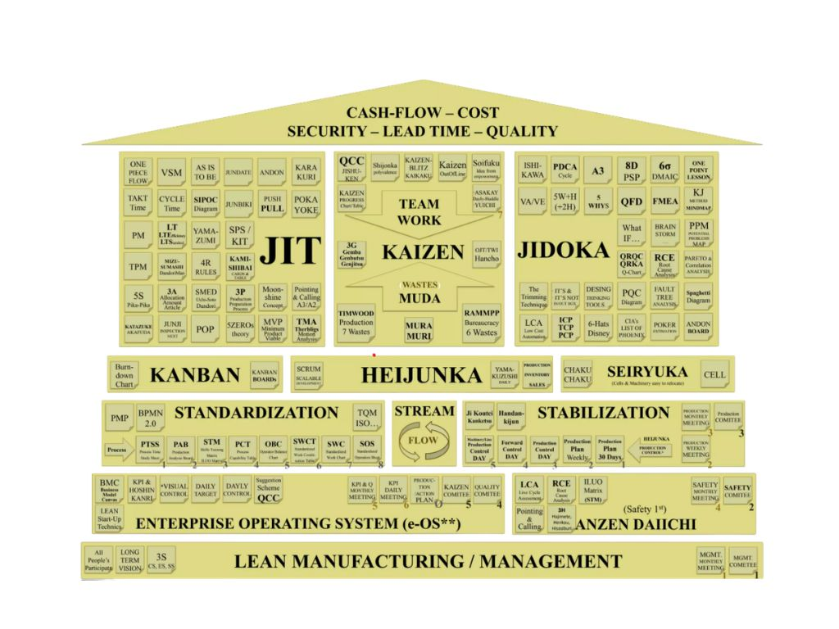
These tools collectively enhance workflow efficiency, reduce non-value-added activities, and improve product quality.

Figure 2.1: Lean Manufacturing Tools Relationship

2.2 SMED Concept

Definition:
SMED (Single Minute Exchange of Dies) is a lean tool developed to reduce setup and changeover time to less than 10 minutes by optimizing machine and process adjustments.
Importance in Manufacturing:
SMED plays a critical role in industries with frequent product changes, especially garments, where styles change rapidly. It enables:
- Faster changeovers between styles
- Reduction in machine downtime
- Increased production flexibility
- Better handling of small batch production

By minimizing start-up losses, SMED improves responsiveness to market demands and enhances overall efficiency.

Parameter | Traditional Method | SMED Method
Setup Time | 20–60 minutes | Less than 10 min
Machine Downtime | High | Low
Flexibility | Low | High
Batch Size | Large | Small
Productivity | Moderate | High
Waste | High | Reduced
Table 2.2: Comparison of Traditional Setup and SMED

2.3 Previous Studies
Various studies across manufacturing sectors highlight the effectiveness of SMED and lean tools:
- In automotive and machining industries, SMED has significantly reduced setup time by separating internal and external activities.
- Research shows that converting internal tasks to external tasks improves machine utilization and reduces idle time.
- Studies also emphasize standardization and simplification of processes as key techniques for changeover reduction.
- Applications of SMED combined with lean tools like Kaizen and 5S have led to measurable improvements in productivity and cost reduction.
However, most studies focus on heavy manufacturing rather than labor-intensive sectors like garments.

2.4 Research Gap
Despite the proven benefits of SMED in various industries, its implementation in the garment sector is still limited.
- Garment manufacturing involves high variability in styles and frequent changeovers, yet systematic SMED adoption is low.
- Existing research lacks detailed studies on applying SMED specifically to sewing lines and apparel production.
- There is a need to explore practical SMED frameworks tailored for garment units to improve efficiency and reduce setup time.
This gap highlights the importance of studying SMED implementation in garment manufacturing to enhance competitiveness and responsiveness.

CHAPTER 3

SMED THEORY & FRAMEWORK

3.1 SMED
Single Minute Exchange of Dies (SMED) is a lean manufacturing technique developed by Shigeo Shingo to reduce setup or changeover time in production processes to less than ten minutes. The term “single minute” does not necessarily mean one minute, but rather any setup completed in a single-digit time frame (i.e., under 10 minutes).
SMED plays a critical role in modern manufacturing environments, especially in industries like textiles and garments, where frequent style changes, small batch production, and dynamic customer demands require high flexibility. By minimizing setup time, SMED enables manufacturers to switch between products quickly without significant downtime.
The primary goal of SMED is to reduce non-productive time, thereby increasing machine availability, improving production flow, and enhancing overall equipment efficiency. It supports lean principles by eliminating waste associated with waiting, unnecessary motion, and inefficient processes.

Implementation of SMED contributes to:
- Reduced production lead time
- Increased responsiveness to market changes
- Improved product quality and consistency
Thus, SMED is not just a time-reduction tool but a strategic approach that enhances competitiveness in fast-paced manufacturing sectors.

3.2 Types of Set-up
Setup activities in SMED are broadly classified into two categories:

1. Internal Set-up

Internal setup refers to activities that can only be performed when the machine is completely stopped. These tasks directly contribute to production downtime and must be minimized or eliminated wherever possible.
Examples include:
- Changing dies, tools, or bobbins
- Adjusting machine settings
- Fixing components inside the machine
Internal setup is critical because it directly affects production efficiency. Excessive internal setup time leads to idle machines, delayed output, and increased operational costs.

2. External Set-up
External setup includes activities that can be performed while the machine is still running, without interrupting production.
Examples include:
- Preparing tools and materials in advance
- Pre-heating equipment
- Arranging components near the workstation
The key objective of SMED is to convert as many internal activities into external ones as possible, thereby significantly reducing machine stoppage time.
This distinction between internal and external setup forms the foundation of SMED implementation and is essential for achieving faster changeovers.

Setup Activities
|
------------------------------------------------------
| |
Internal Setup External Setup
(Machine Stopped) (Machine Running)

Figure 3.1: Internal vs External Setup

3.3 SMED Stages
The implementation of SMED follows a systematic four-stage approach:

Stage 1: Analysis of Current Setup Process
In this stage, the entire setup process is observed and documented in detail. Techniques such as time study, video recording, and process mapping are used to identify each step involved in changeover.
The objective is to:
- Understand existing inefficiencies
- Identify bottlenecks
- Measure current setup time
- This stage provides a baseline for improvement

Stage 2: Separation of Internal and External Activities
Once the process is analyzed, all setup tasks are categorized into internal and external activities.
The goal is to:
- Clearly distinguish tasks that require machine stoppage
- Identify tasks that can be performed while the machine is running
This step is crucial because it lays the groundwork for reducing downtime.

Stage 3: Conversion of Internal to External Activities
In this stage, efforts are made to convert internal setup tasks into external ones wherever possible.
For example:
- Pre-assembling tools before machine stoppage
- Using quick-release mechanisms
- Standardizing parts and procedures
This stage significantly reduces the time the machine remains idle and improves operational efficiency.

Stage 4: Streamlining and Optimization
The final stage focuses on simplifying and improving all setup activities, both internal and external.
This involves:
- Eliminating unnecessary movements
- Using ergonomic tools and fixtures
- Implementing parallel operations
- Standardizing procedures
The aim is to achieve a fast, efficient, and repeatable setup process with minimal variation.

CHAPTER 4

METHODOLOGY
4.1 Study Area
The study was carried out in a garment production unit, focusing specifically on the sewing section where frequent style changes occur. The production line selected for analysis consists of multiple sewing machines arranged in a progressive bundle system, handling operations such as stitching, trimming, and finishing.
The chosen line produces shirts, where changeovers occur due to:
- Style variation
- Frequent non- standard operations
- Fabric types
- Thread color adjustments
This area was selected because it experiences high setup time losses, making it ideal for implementing Single Minute Exchange of Dies (SMED).

4.2 Data Collection
To understand the current inefficiencies, multiple data collection techniques were used:

1. Time Study
- A stopwatch method was used to record the time taken for each changeover activity
- Observations were repeated 5–7 times to ensure accuracy
- Average time values were calculated

2. Operator Observation
- Operators were closely monitored during changeover
- Delays due to manual adjustments, waiting time, and searching tools were noted
- Skill variations between operators were also recorded

4.3 Current Process Analysis
The existing changeover process was analyzed in detail by breaking it into individual steps.

Typical Changeover Activities
- Machine stopping
- Removal of previous thread and attachments
- Needle replacement
- Thread reloading
- Machine cleaning
- Trial stitching and adjustments

Activity | Time(Minutes)
Machine stoppage | 2
Thread removal | 5
Needle change | 4
Thread setting | 6
Machine cleaning | 5
Trial & adjustment | 8
Total Time | 30 minutes
Table 4.1: Existing Changeover Time

Key Problems Identified
- Most activities performed as internal setup (machine stopped)
- Lack of standard procedure
- Operators searching for tools
- No pre-preparation before changeover
- Excessive trial-and-error adjustments

4.4 Tools Used
To analyze and improve the process, the following tools were applied:

1. Stopwatch / Time Study
- Used for measuring precise time of each activity
- Helped identify bottlenecks

2. Process Charts
- Flow process charts were created to visualize:
  - Sequence of operations
  - Delays and redundancies

3. Work Sampling
- Random observations taken to identify:
  - Idle time
  - Non-value-added activities

4. Video Analysis
- Slow-motion review of recorded process
- Helped detect:
  - Unnecessary movements
  - Repeated adjustments

4.5 Implementation of SMED
The SMED methodology was applied in a step-by-step structured manner:

Step 1: Separate Internal and External Activities
- Internal: Activities done when machine is stopped
- External: Activities done while machine is running

Step 2: Convert Internal to External
- Tools, threads, and needles prepared in advance
- Machine cleaning partially done before stopping

Step 3: Streamline Internal Activities
- Standardized procedures introduced
- Quick-change attachments used
- Operators trained for faster adjustments

Step 4: Improve Efficiency
- Tool kits placed near machines
- Visual guides for thread setting
- Reduced trial time using pre-settings

CHAPTER 5
ANALYSIS OF CURRENT SYSTEM

5.1 Existing Changeover Process

Time Study of Non-Standard Operations (Before SMED Implementation)
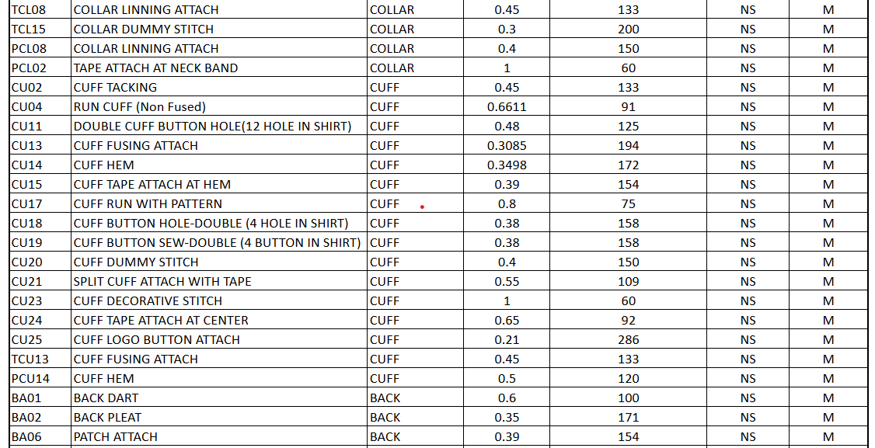
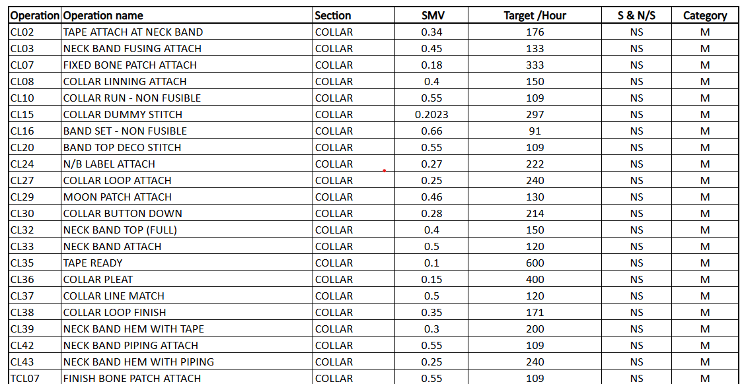
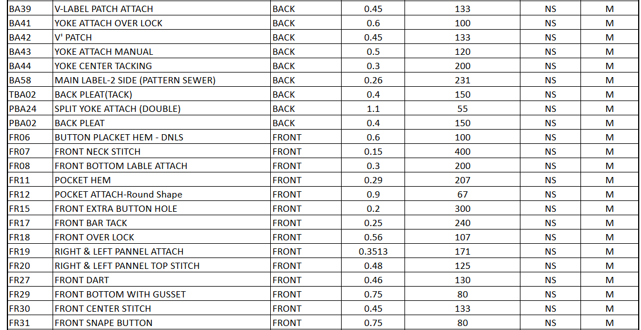
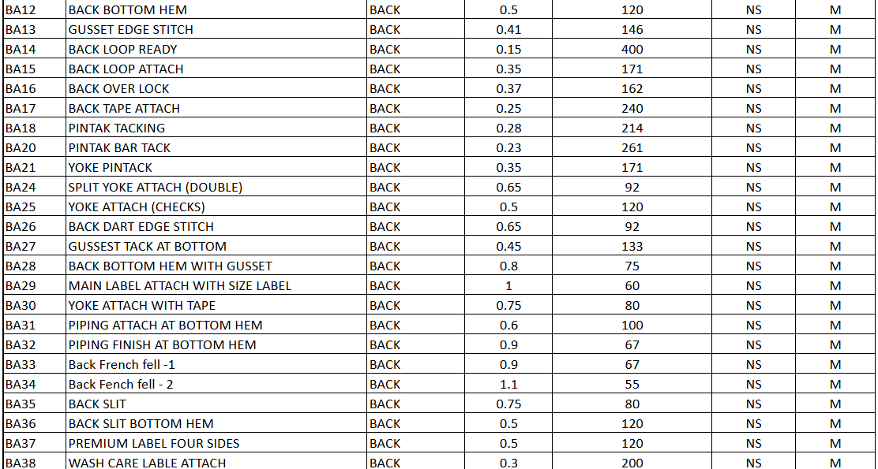

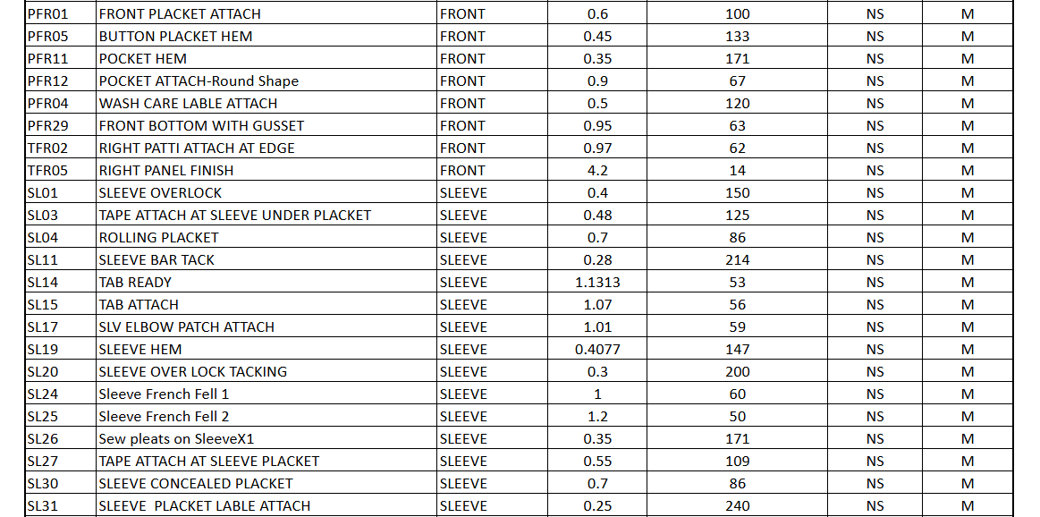
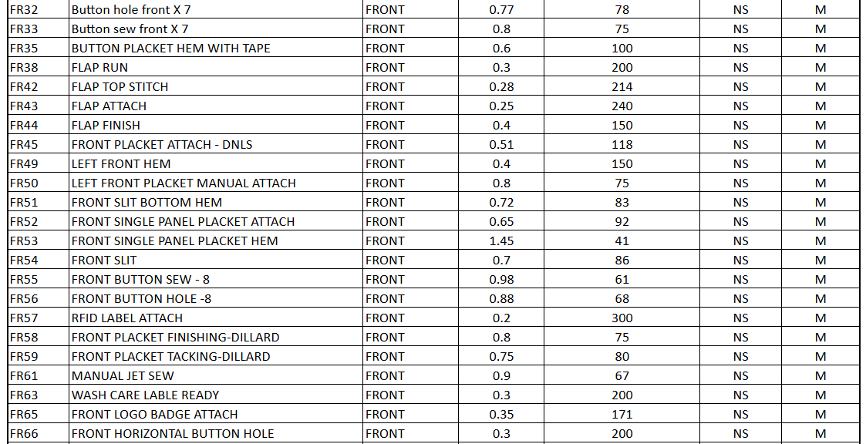

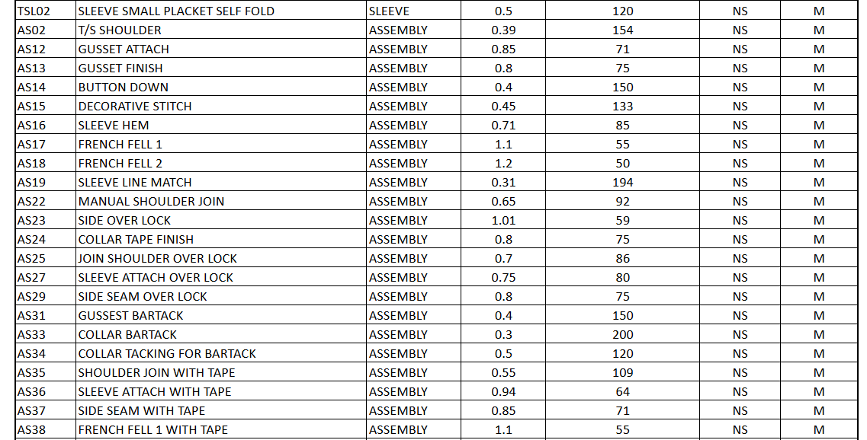
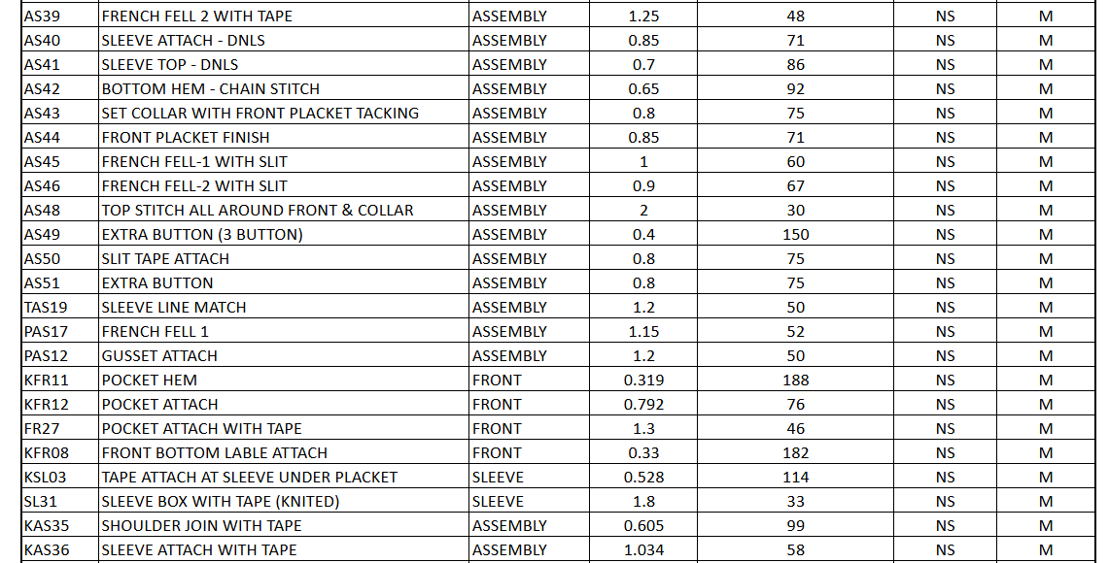
Total machines count : 1752 machines

5.2 Machines Details
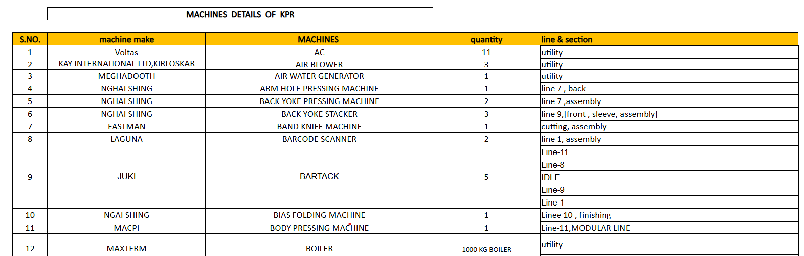

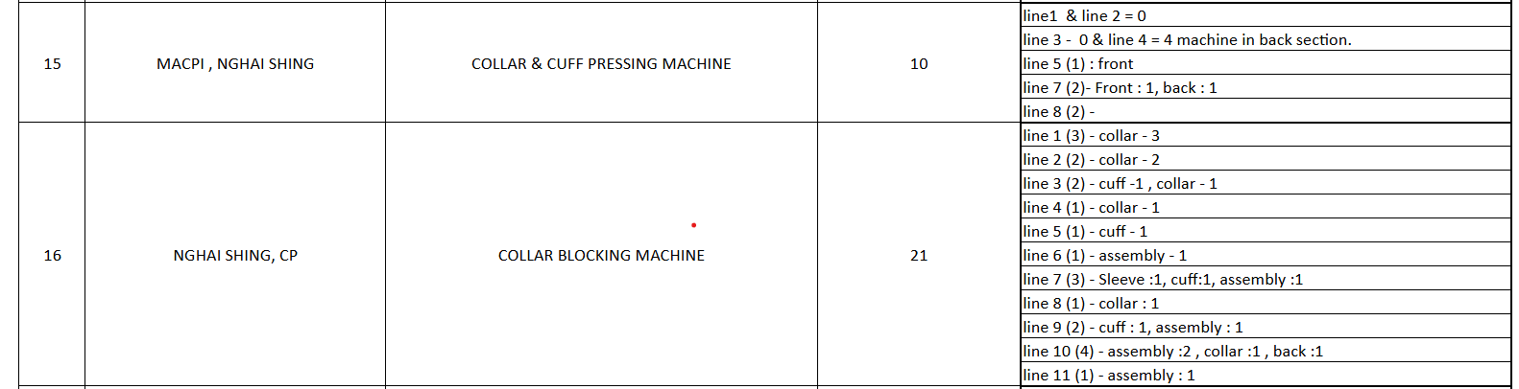
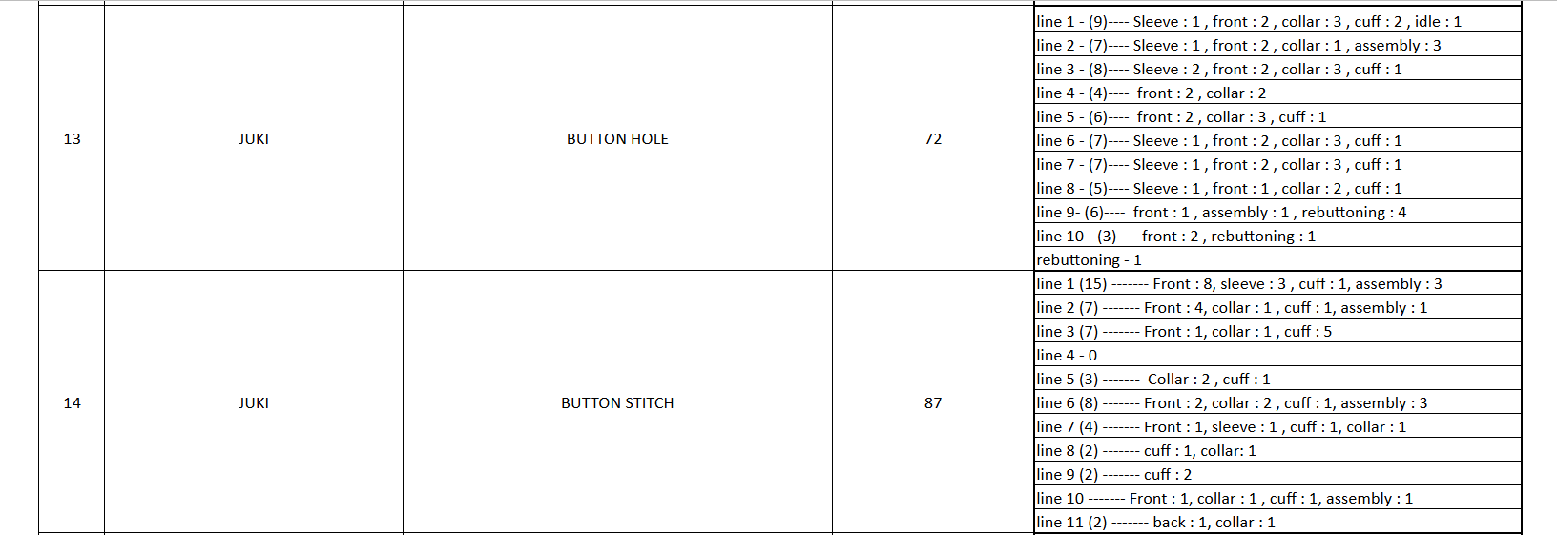

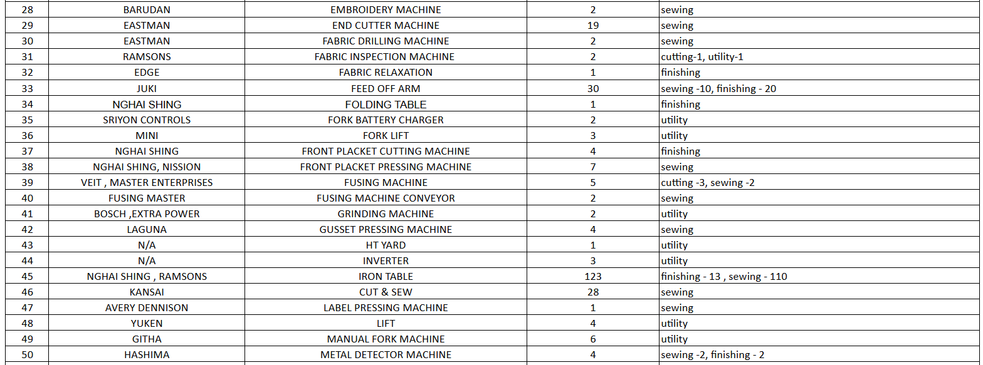
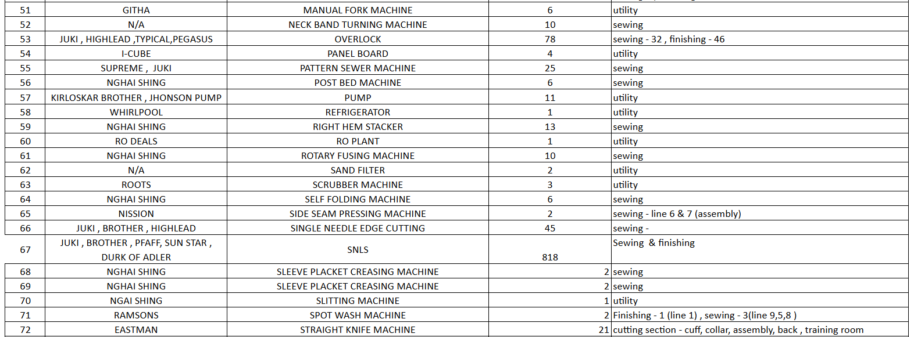
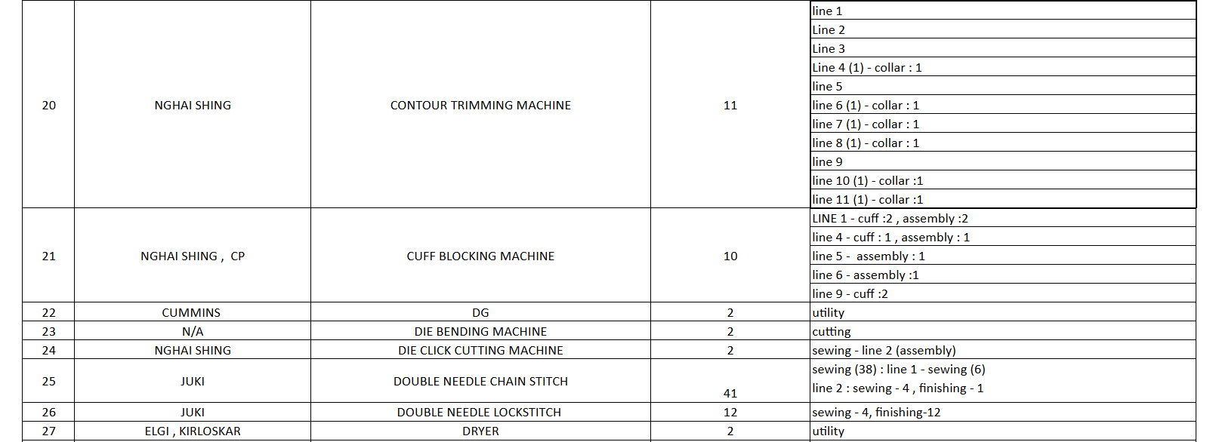
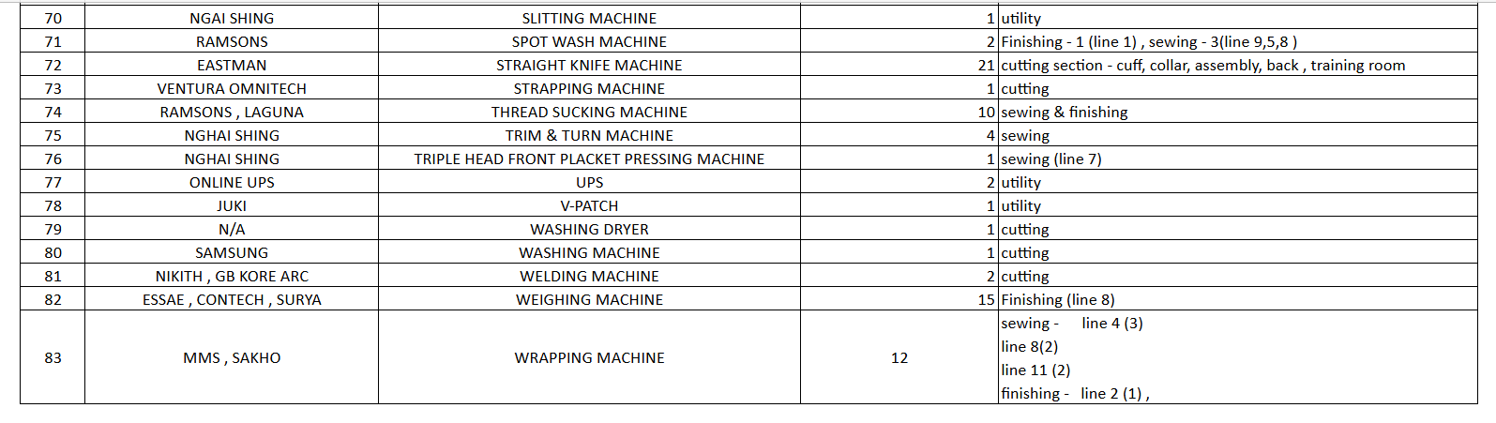

5.3 Identification of Waste

1. Idle Time
- Operator spends 60 sec searching for bobbin
- Machine remains stopped unnecessarily
- Loss of productivity

2. Motion Waste
- Walking to storage (40 sec)
- Returning with bobbin (35 sec)
Total unnecessary movement = 75 sec

3. Waiting Waste
- Trial and adjustment delays (60 sec)
- Minor pauses between steps (~20 sec cumulative)
Total waiting waste ≈ 80 sec

4. Overprocessing
- Cleaning done inconsistently (sometimes repeated

5.4 Problems Identified

1. Delays in Changeover
- Searching tools/materials during machine stop
- No pre-preparation of bobbins

2. Inefficient Setup Process
- No fixed sequence followed
- Operator-dependent variation

3. Lack of Standardization
- No SOP (Standard Operating Procedure)
- Different operators follow different methods

4. Poor Workplace Organization
- No fixed location for bobbins/tools
- Absence of 5S implementation

5. No External Setup Activities
- Everything done after stopping machine
- Huge opportunity loss for SMED improvement

CHAPTER 5
RESULT AND ANALYSIS

6.1 INTERNAL AND EXTERNAL ACTIVITIES – ANALYSIS AND RECOMMENDATIONS

Activity | Current Category | Can be Converted? (Yes/No) | Proposed Category | Remarks
Guide setup | Internal | Yes | External | Pre-set on standby machine
Thread matching | Internal | Yes | External | Thread kit prepared in advance
Tape roll loading | Internal | Yes | External | Keep tape ready before changeover
Machine cleaning | Internal | No | Internal | Essential before next style
Needle change | Internal | No | Internal | Safety-critical task
Folder alignment | Internal | Yes | Internal | Use fixed guide for faster setup
Trial stitching | Internal | No | Internal | Quality verification required
Tool collection | External | - | External | Done before machine stops
Temperature setting | Internal | No | Internal | Must be set on machine
Pressure setting | Internal | No | Internal | Dependent on fabric type
Fusing tape loading | Internal | Yes | External | Prepare tape roll beforehand
Machine cleaning | Internal | No | Internal | Required for bonding quality
Trial fusing check | Internal | No | Internal | Quality validation needed
Material preparation | External | - | External | Cut panels ready before changeover
Tool arrangement | External | - | External | Keep tools near workstation
Interlining matching | Internal | Yes | External | Issue correct interlining kit
Time/Speed setting | Internal | Yes | Internal | Use preset program if available
Patch template setup | Internal | Yes | External | Prepare template before changeover
Thread matching | Internal | Yes | External | Thread kit issued in advance
Bone patch alignment | Internal | No | Internal | Critical for accuracy
Machine cleaning | Internal | No | Internal | Required before next style
Needle change | Internal | No | Internal | Safety and fabric specific
Folder / guide setting | Internal | Yes | Internal | Use fixed guide/stoppers
Trial stitching | Internal | No | Internal | Quality check required
Tool arrangement | External | - | External | Prepare tool kit beforehand
Material fetching | External | - | External | Patch bundles ready before stop
Marker reference checking | Internal | Yes | External | Pre-marking done before setup
Guide setup (collar folder) | Internal | Yes | External | Pre-set folder on standby machine
Thread matching | Internal | Yes | External | Thread kit prepared beforehand
Lining bundle arrangement | Internal | Yes | External | Bundle prepared before changeover
Machine cleaning | Internal | No | Internal | Required for quality stitching
Needle change | Internal | No | Internal | Safety-critical
Folder alignment | Internal | Yes | Internal | Use fixed gauge for quick setting
Trial stitching on collar | Internal | No | Internal | Quality check mandatory
Tool preparation | External | - | External | Tools arranged in advance
Material fetching | External | - | External | Lining & collar parts ready
Guide/folder setup | Internal | Yes | External | Pre-set using duplicate folder
Thread matching | Internal | Yes | External | Thread kit issued before changeover
Collar part alignment check | Internal | No | Internal | Critical for quality
Machine cleaning | Internal | No | Internal | Required before next run
Needle change | Internal | No | Internal | Safety-critical task
Stitch length adjustment | Internal | Yes | Internal | Use preset dial marking
Trial run (sample stitching) | Internal | No | Internal | Quality verification
Tool preparation | External | - | External | Prepared in advance
Material (collar pieces) fetching | External | - | External | Kitting done before stop
Thread stand setup | External | - | External | Done prior to changeover
Guide setting (collar shape) | Internal | Yes | External | Pre-set guide on standby machine
Thread matching | Internal | Yes | External | Thread kit prepared beforehand
Dummy pattern alignment | Internal | No | Internal | Requires operator precision
Machine cleaning | Internal | No | Internal | Essential before stitching
Pressure foot adjustment | Internal | Yes | Internal | Use marked settings for quick adjust
Trial stitching | Internal | No | Internal | Quality check required
Tool preparation | External | - | External | Prepared before changeover
Collar bundle arrangement | External | - | External | Material staged in advance
Marking reference check | External | - | External | Done prior to machine stop
Band piece loading | Internal | Yes | External | Pre-arrange cut bands before changeover
Guide setting | Internal | Yes | External | Pre-set guide on standby machine
Thread matching | Internal | Yes | External | Thread kit prepared in advance
Machine cleaning | Internal | No | Internal | Must be done before stitching
Needle change | Internal | No | Internal | Safety and quality requirement
Folder adjustment | Internal | Yes | Internal | Use fixed folder position stopper
Trial stitching | Internal | No | Internal | Required for quality approval
Tool arrangement | External | - | External | Prepare tools before changeover
Material fetching | External | - | External | Ensure band bundles ready
Presser foot change | Internal | Yes | External | Keep alternate foot ready before stop
Thread color setup | Internal | Yes | External | Thread stand pre-loaded
Deco stitch program selection | Internal | No | Internal | Machine dependent setup
Fabric sample check | Internal | No | Internal | Required for accuracy
Guide marking adjustment | Internal | Yes | Internal | Introduce marked scale for quick setting
Bobbin winding | Internal | Yes | External | Pre-wound bobbins available
Machine lubrication check | Internal | No | Internal | Mandatory maintenance step
Tool arrangement | External | - | External | Organized tool tray used
Pattern sheet reference | External | - | External | Displayed near machine
Material alignment prep | External | - | External | Done before changeover
Spare needle availability | External | - | External | Kept in advance kit
Label checking | Internal | Yes | External | Labels verified before line stop
Thread replacement | Internal | Yes | External | Thread cone kept ready
Machine cleaning | Internal | No | Internal | Required for quality
Label positioning setup | Internal | No | Internal | Needs machine alignment
Guide adjustment | Internal | Yes | Internal | Introduce preset guide marks
Trial run | Internal | No | Internal | Mandatory for QC approval
Label bundle arrangement | External | - | External | Prepared by helper
Tool arrangement | External | - | External | Tool kit maintained at station
Work instruction review | External | - | External | Displayed SOP sheet
Loop folder setup | Internal | Yes | External | Pre-set folder on spare machine
Thread color change | Internal | Yes | External | Thread kit issued before stop
Loop cutting preparation | Internal | Yes | External | Pre-cut loops kept ready
Machine cleaning | Internal | No | Internal | Required for quality
Needle positioning | Internal | No | Internal | Precision task
Guide adjustment | Internal | Yes | Internal | Use marked settings for repeat styles
Trial run stitching | Internal | No | Internal | Essential for loop strength check
Tool arrangement | External | - | External | Organized before changeover
Loop bundle staging | External | - | External | Material issued in advance
Attachment marking check | External | No | External | Done during running
Air pressure check | External | No | External | Verified beforehand
Patch alignment marking | Internal | Yes | External | Marking template used before changeover
Thread shade verification | Internal | Yes | External | Thread card issued prior
Patch bundle arrangement | Internal | Yes | External | Pre-arranged in sequence
Presser foot adjustment | Internal | No | Internal | Required as per fabric thickness
Hoop/frame setting | Internal | Yes | Internal | Quick-lock mechanism can reduce time
Needle positioning | Internal | No | Internal | Precision required for patch curve
Trial run on scrap | Internal | No | Internal | Mandatory for quality approval
Tool preparation | External | - | External | Organized in tool kit
Material issue | External | - | External | Issued before machine stops
Machine oil check | External | - | External | Done during running condition
Workstation cleaning | External | - | External | Done parallelly
Button feeder setup | Internal | Yes | External | Pre-load feeder before changeover
Thread color change | Internal | Yes | External | Thread stand prepared in advance
Button size adjustment | Internal | No | Internal | Needs precision during setup
Folder/guide change | Internal | Yes | Internal | Introduce quick-lock mechanism
Machine oil check | Internal | No | Internal | Must be done before operation
Trial button stitching | Internal | No | Internal | Ensures button strength & alignment
Program setting (if semi-auto) | Internal | Yes | External | Pre-set program for next style
Button stock arrangement | External | - | External | Arrange buttons in kit form
Tool preparation | External | - | External | Keep tools ready at workstation
Sample verification | External | - | External | Approved sample kept ready
Cleaning workplace | External | - | External | Done before shutdown
Neck band folder setup | Internal | Yes | External | Pre-set folder on spare attachment
Top stitch thread change | Internal | Yes | External | Thread kit issued before stop
Fabric alignment check | Internal | No | Internal | Critical for seam accuracy
SPI (stitch per inch) adjustment | Internal | No | Internal | Quality dependent setting
Pressure foot adjustment | Internal | Yes | Internal | Use marked scale for faster setup
Edge guide positioning | Internal | Yes | External | Pre-mark guide positions
Trial run on sample | Internal | No | Internal | Mandatory for appearance check
Machine cleaning (lint removal) | Internal | No | Internal | Required for smooth stitching
Accessory staging (bands) | External | - | External | Prepared in bundles beforehand
Tool kit arrangement | External | - | External | Standard tool tray at station
Approved sample placement | External | - | External | Reference sample kept ready
Thread cone replacement | External | - | External | Done during running batch
Workstation inspection | External | - | External | Checked before changeover
Neck band folder setup | Internal | Yes | External | Pre-adjust folder on spare machine
Fabric panel alignment check | Internal | No | Internal | Critical for quality alignment
Thread replacement | Internal | Yes | External | Thread cone kept ready in advance
SPI & tension adjustment | Internal | No | Internal | Requires machine running condition
Guide plate fixing | Internal | Yes | Internal | Introduce marked positioning system
Machine cleaning | Internal | No | Internal | Basic maintenance required
Trial run with sample | Internal | No | Internal | Mandatory for seam accuracy
Operator instruction briefing | Internal | Yes | External | Explain changes before stop
Component bundling | External | - | External | Pre-bundled neck bands issued
Tool arrangement | External | - | External | Standard toolkit at station
Quality sample placement | External | - | External | Approved sample displayed
Line clearance | External | - | External | Done prior to style change
Tape width selection | Internal | Yes | External | Prepare tape roll as per spec beforehand
Measuring tape length | Internal | Yes | External | Pre-cut lengths using template
Tape cutting setup | Internal | No | Internal | Requires alignment for accuracy
Machine blade check | Internal | No | Internal | Safety and sharpness check mandatory
Initial sample cutting | Internal | No | Internal | Verification of correct size
Tape bundling | External | - | External | Bundle prepared before line feeding
Label marking on bundles | External | - | External | Color coding for easy identification
Material fetching | External | - | External | Pre-staged near workstation
Tool arrangement | External | - | External | Scissors, scale kept ready
Workstation cleaning | External | - | External | Done prior to changeover
Tape roll inspection | External | - | External | Check defects before use
Pleat marking alignment | Internal | Yes | External | Pre-mark panels before feeding
Folder setting | Internal | No | Internal | Requires precise adjustment on machine
Fabric panel arrangement | Internal | Yes | External | Bundle preparation before start
Thread replacement | Internal | Yes | External | Thread stand setup beforehand
Machine speed adjustment | Internal | No | Internal | Depends on fabric type
Trial pleat stitching | Internal | No | Internal | Quality check for symmetry
Guide positioning | Internal | Yes | Internal | Use reference scale for faster setup
Panel stacking | External | - | External | Stack in correct orientation
Tool readiness | External | - | External | Keep measuring scale & tools ready
Sample reference check | External | - | External | Approved pleat sample displayed
Workstation cleaning | External | - | External | Done during previous run
Extra fabric segregation | External | - | External | Avoid mixing styles
Collar panel alignment setup | Internal | No | Internal | Requires precision handling
Guide plate adjustment | Internal | Yes | Internal | Use calibrated marking for quick set
Thread tension setting | Internal | Yes | External | Pre-adjust thread tension unit
Fabric bundle positioning | Internal | Yes | External | Arrange bundles before stop
Needle position check | Internal | No | Internal | Critical for stitch accuracy
Trial seam matching | Internal | No | Internal | Visual quality verification needed
Marking reference alignment | Internal | Yes | External | Pre-mark collars before feeding
Pressure foot adjustment | Internal | Yes | Internal | Introduce preset pressure levels
Tool staging | External | - | External | Tools arranged beside machine
Bundle tagging verification | External | - | External | Done during previous operation
Workstation cleaning | External | - | External | Pre-clean before style change
Reference sample placement | External | - | External | Keep approved sample visible
Thread cone arrangement | External | - | External | Prepare thread stand in advance
Loop folder setup | Internal | Yes | External | Keep pre-adjusted folder ready
Thread change (loop matching) | Internal | Yes | External | Thread cone staged beforehand
Bartack program selection | Internal | Yes | External | Pre-load program for next style
Loop length adjustment | Internal | No | Internal | Requires precise measurement
Needle & bobbin check | Internal | No | Internal | Critical for stitch quality
Trial loop stitching | Internal | No | Internal | Mandatory for strength testing
Loop pieces arrangement | External | - | External | Prepared in bundles before stop
Tool positioning | External | - | External | Tools placed on workstation tray
Sample loop reference check | External | - | External | Approved sample kept ready
Workstation cleaning | External | - | External | Done during running style end
Tape folding setup | Internal | Yes | External | Pre-fold tape using manual jig
Hem guide adjustment | Internal | No | Internal | Requires precision alignment
Thread cone replacement | Internal | Yes | External | Thread stand pre-arranged
Looper threading | Internal | No | Internal | Needs machine stopped
Tape alignment trial | Internal | No | Internal | Critical for finish quality
Machine cleaning | Internal | Yes | External | Do cleaning during last batch
Tape roll inspection | External | - | External | Checked before shift
Tool kit positioning | External | - | External | Standardized tool tray
Material bundling | External | - | External | Cut pieces prepared in advance
Workstation layout check | External | - | External | 5S maintained before changeover
Piping roll preparation | Internal | Yes | External | Cut & prepare piping roll beforehand
Folder (piping foot) change | Internal | No | Internal | Requires precise fitting
Thread replacement | Internal | Yes | External | Thread stand arranged before stop
Needle positioning | Internal | No | Internal | Accuracy required for stitch quality
Machine speed adjustment | Internal | Yes | External | Pre-set standard RPM for style
Trial run on scrap | Internal | No | Internal | Ensures piping alignment
Fabric bundle staging | External | - | External | Bundle prepared near workstation
Tool kit arrangement | External | - | External | All tools placed in shadow board
Piping color verification | External | - | External | Color checked before start
Workstation cleaning | External | - | External | Done during last production run
Hem guide setting | Internal | Yes | External | Pre-adjust guide using reference sample
Piping alignment check | Internal | No | Internal | Critical for seam finish quality
Looper thread change | Internal | Yes | External | Pre-thread spare looper setup
Knife position adjustment | Internal | No | Internal | Requires machine stop & precision
Differential feed tuning | Internal | Yes | Internal | Standardize based on fabric type
Pressure foot calibration | Internal | No | Internal | Ensures smooth feeding of layers
Trial hemming with piping | Internal | No | Internal | Needed for visual and strength check
Stitch density adjustment | Internal | Yes | External | Pre-set SPI for style
Material bundle positioning | External | - | External | Organized near operator beforehand
Accessory (piping) staging | External | - | External | Sorted by color & size
Air blow cleaning | External | - | External | Done during previous run end
Bone patch alignment setup | Internal | No | Internal | Precision critical for placement
Clamp adjustment | Internal | Yes | Internal | Introduce preset clamp markings
Button program selection | Internal | Yes | External | Pre-load program for next style
Thread cone change | Internal | Yes | External | Thread kit prepared beforehand
Needle replacement | Internal | No | Internal | Safety & stitch quality requirement
Trial patch fixing | Internal | No | Internal | Required for strength verification
Sensor calibration (BT machine) | Internal | No | Internal | Machine-dependent accuracy step
Air pressure check | Internal | Yes | External | Pre-check compressor settings
Patch bundle arrangement | External | - | External | Bundle sorted by size beforehand
Tool positioning | External | - | External | Keep tools within arm’s reach
Lining piece alignment | Internal | No | Internal | Accuracy impacts final shape
Guide plate setup | Internal | Yes | External | Pre-set guide for next style
Thread tension setting | Internal | Yes | Internal | Mark standard tension levels
Needle check | Internal | No | Internal | Required for quality stitch
Sample run | Internal | No | Internal | Essential for alignment check
Fabric direction marking | Internal | Yes | External | Mark before machine stops
Bundle preparation | External | - | External | Lining pieces stacked in order
Tool arrangement | External | - | External | Use dedicated tool tray
Interlining check | External | - | External | Verify before operation
Cleaning area | External | - | External | Done parallelly
Looper thread change | Internal | Yes | External | Prepare thread cones in advance
Stitch density setting | Internal | Yes | External | Standardize SPI settings
Knife position adjustment | Internal | No | Internal | Precision critical
Pressure foot setting | Internal | Yes | Internal | Use reference markings
Trial stitch on scrap | Internal | No | Internal | Ensures seam strength
Collar piece staging | External | - | External | Prepared in sequence
Thread kit setup | External | - | External | Color-coded thread kit
Tool placement | External | - | External | Shadow board usage
Sample approval | External | - | External | Keep approved sample ready
Workstation cleaning | External | - | External | Done during last batch
Flatlock guide setting | Internal | No | Internal | Requires exact positioning
Thread path setup | Internal | Yes | External | Pre-thread machine partially
Differential feed adjustment | Internal | No | Internal | Fabric dependent
Speed calibration | Internal | Yes | External | Set standard RPM
Trial seam check | Internal | No | Internal | Check stretch & finish
Needle alignment | Internal | No | Internal | Critical for seam quality
Fabric layering setup | Internal | Yes | Internal | Use template for layering
Material staging | External | - | External | Prepared beforehand
Tool kit ready | External | - | External | Placed near operator
Quality sample check | External | - | External | Reference sample available
Tape roll replacement | Internal | Yes | External | Prepare roll in advance
Guide plate adjustment | Internal | No | Internal | Requires precision fitting
Thread setup | Internal | Yes | External | Thread stand pre-arranged
Needle check | Internal | No | Internal | Safety requirement
Tape alignment trial | Internal | No | Internal | Quality check step
Bundle staging | External | - | External | Material placed near machine
Tool arrangement | External | - | External | Shadow board system used
Tape width verification | External | - | External | Checked before changeover
Cleaning machine | External | - | External | Done during last batch
Helper support prep | External | - | External | Assistant prepares materials
Tack program selection | Internal | Yes | External | Pre-select program
Clamp positioning | Internal | No | Internal | Needs exact placement
Thread color change | Internal | Yes | External | Thread kit issued
Needle adjustment | Internal | No | Internal | Quality critical
Trial tacking | Internal | No | Internal | Strength testing
Air pressure setting | Internal | Yes | External | Pre-set compressor
Cuff bundle sorting | External | - | External | Prepared by helper
Tool setup | External | - | External | Tools kept ready
Sample approval check | External | - | External | Reference sample provided
Looper thread setup | Internal | Yes | External | Thread pre-loaded
Cuff edge guide setup | Internal | No | Internal | Needs accuracy
Differential feed adjustment | Internal | Yes | Internal | Use standard marking
Knife position check | Internal | No | Internal | Cutting accuracy required
Trial seam run | Internal | No | Internal | Ensures seam quality
Fabric bundle preparation | External | - | External | Sorted before start
Thread cone arrangement | External | - | External | Ready on standby
Tool placement | External | - | External | Organized in kit
Machine cleaning | External | - | External | Done before changeover
Operator briefing | External | - | External | Explain style differences
Button hole program selection | Internal | Yes | External | Pre-load design program
Knife size adjustment | Internal | No | Internal | Depends on fabric thickness
Thread setup | Internal | Yes | External | Thread stand prepared
Clamp alignment | Internal | No | Internal | Accuracy required for 12 holes
Machine calibration | Internal | No | Internal | Essential for uniform holes
Trial buttonhole stitching | Internal | No | Internal | Quality validation
Marking reference alignment | Internal | Yes | External | Pre-mark templates used
Needle check | Internal | No | Internal | Safety requirement
Speed setting adjustment | Internal | Yes | External | Standard speed preset
Cuff bundle staging | External | - | External | Bundle prepared beforehand
Tool arrangement | External | - | External | Tools placed near machine
Sample approval check | External | - | External | Approved sample ready
Temperature setting | Internal | No | Internal | Material dependent
Pressure adjustment | Internal | Yes | External | Standard preset chart
Fusing sheet placement | Internal | No | Internal | Needs precision
Timer setting | Internal | Yes | External | Pre-set cycle timing
Machine warm-up | Internal | No | Internal | Mandatory step
Trial fusing check | Internal | No | Internal | Bonding verification
Cuff panel arrangement | External | - | External | Prepared in advance
Fusing material staging | External | - | External | Sorted by size
Tool preparation | External | - | External | Ready before start
Cleaning belt surface | External | - | External | Done pre-changeover
Guide setting | Internal | Yes | External | Pre-set hemming guide
Thread change | Internal | Yes | External | Thread kit ready
Needle check | Internal | No | Internal | Essential
Machine cleaning | Internal | No | Internal | Quality requirement
Trial hem stitching | Internal | No | Internal | Ensures fold accuracy
Fabric bundle arrangement | External | - | External | Prepared earlier
Tool kit setup | External | - | External | Standard tool layout
Hem width marking | External | - | External | Use template marking
Workstation cleaning | External | - | External | Done before stop
Material flow setup | External | - | External | Line balancing done
Tape roll setup | Internal | Yes | External | Prepare tape roll beforehand
Folder alignment | Internal | No | Internal | Precision required
Thread setup | Internal | Yes | External | Thread prepared in advance
Needle positioning | Internal | No | Internal | Safety step
Machine speed tuning | Internal | Yes | External | Standard preset
Trial stitching | Internal | No | Internal | Check tape alignment
Cuff panel staging | External | - | External | Ready near machine
Tool kit arrangement | External | - | External | Shadow board system
Tape quality check | External | - | External | Pre-inspection
Cleaning workstation | External | - | External | Done earlier
Pattern guide setting | Internal | Yes | External | Use pre-marked guides
Thread color matching | Internal | Yes | External | Thread kit prepared
Looper adjustment | Internal | No | Internal | Machine-specific accuracy
Knife setting | Internal | Yes | Internal | Introduce stopper system
Trial stitching | Internal | No | Internal | Check pattern consistency
Speed synchronization | Internal | Yes | External | Preset machine speed
Fabric panel staging | External | - | External | Prepared in bundle form
Tool arrangement | External | - | External | Shadow board system
Pattern reference check | External | - | External | Sample kept ready
Workstation setup | External | - | External | Done before start
Material alignment | External | - | External | Pre-arranged panels
Program selection | Internal | Yes | External | Pre-load program
Knife adjustment | Internal | No | Internal | Fabric dependent
Thread setup | Internal | Yes | External | Thread ready beforehand
Clamp alignment | Internal | No | Internal | Accuracy needed
Trial stitching | Internal | No | Internal | Check hole quality
Needle inspection | Internal | No | Internal | Safety requirement
Speed setting | Internal | Yes | External | Standard preset
Bundle staging | External | - | External | Prepared in advance
Tool positioning | External | - | External | Nearby placement
Sample verification | External | - | External | Approved sample ready
Button feeder loading | Internal | Yes | External | Pre-load feeder
Program setting | Internal | Yes | External | Pre-select stitch pattern
Clamp positioning | Internal | No | Internal | Precision required
Thread replacement | Internal | Yes | External | Thread kit ready
Trial stitching | Internal | No | Internal | Check stitch strength
Sensor calibration | Internal | No | Internal | Machine dependent
Button arrangement | External | - | External | Sorted beforehand
Tool setup | External | - | External | Organized tools
Sample check | External | - | External | Approved sample ready
Workstation cleaning | External | - | External | Done earlier
Guide setup | Internal | Yes | External | Pre-set guide
Thread setup | Internal | Yes | External | Thread kit ready
Needle check | Internal | No | Internal | Safety requirement
Machine cleaning | Internal | No | Internal | Quality step
Trial stitching | Internal | No | Internal | Ensure dummy stitch look
Fabric staging | External | - | External | Prepared in bundles
Tool arrangement | External | - | External | Standard layout
Marking alignment | External | - | External | Use template
Workstation cleaning | External | - | External | Done earlier
Material flow setup | External | - | External | Pre-balanced line
Tape roll setup | Internal | Yes | External | Prepare tape roll beforehand
Split cuff alignment | Internal | No | Internal | Precision required
Guide setting | Internal | Yes | External | Pre-set guide system
Thread setup | Internal | Yes | External | Thread kit ready
Needle positioning | Internal | No | Internal | Safety step
Trial stitching | Internal | No | Internal | Check tape alignment
Machine cleaning | Internal | No | Internal | Quality requirement
Fabric staging | External | - | External | Prepared bundles
Tool kit setup | External | - | External | Shadow board
Tape inspection | External | - | External | Pre-check quality
Pattern setup | Internal | Yes | External | Pre-load stitch design
Thread color change | Internal | Yes | External | Prepare thread kit
Guide adjustment | Internal | No | Internal | Design accuracy needed
Needle change | Internal | No | Internal | Safety requirement
Trial stitching | Internal | No | Internal | Check design quality
Speed adjustment | Internal | Yes | External | Preset machine speed
Fabric staging | External | - | External | Prepared beforehand
Tool arrangement | External | - | External | Standard layout
Sample reference | External | - | External | Approved sample ready
Workstation cleaning | External | - | External | Done earlier
Tape positioning | Internal | Yes | External | Pre-mark center line
Folder setup | Internal | No | Internal | Precision needed
Thread setup | Internal | Yes | External | Thread ready
Needle check | Internal | No | Internal | Safety step
Trial stitching | Internal | No | Internal | Check center alignment
Panel staging | External | - | External | Prepared bundles
Tool kit setup | External | - | External | Standard layout
Tape inspection | External | - | External | Quality checked
Workstation prep | External | - | External | Done earlier
Material flow setup | External | - | External | Line balanced
Logo button loading | Internal | Yes | External | Pre-load feeder
Program selection | Internal | Yes | External | Pre-set program
Clamp alignment | Internal | No | Internal | Accuracy required
Thread setup | Internal | Yes | External | Thread kit ready
Trial stitching | Internal | No | Internal | Check logo alignment
Sensor setup | Internal | No | Internal | Machine dependent
Needle check | Internal | No | Internal | Safety step
Button arrangement | External | - | External | Sorted beforehand
Tool setup | External | - | External | Organized tools
Sample verification | External | - | External | Approved sample ready
Temperature setting | Internal | No | Internal | Material dependent
Pressure setup | Internal | Yes | External | Use preset chart
Timer adjustment | Internal | Yes | External | Pre-set timing
Sheet placement | Internal | No | Internal | Precision needed
Trial bonding | Internal | No | Internal | Check adhesion
Panel staging | External | - | External | Prepared beforehand
Fusing material setup | External | - | External | Sorted materials
Tool arrangement | External | - | External | Ready tools
Machine cleaning | External | - | External | Done earlier
Workstation prep | External | - | External | Pre-changeover setup
Hem guide setting | Internal | Yes | External | Pre-set guide before stop
Thread setup | Internal | Yes | External | Thread kit ready
Needle inspection | Internal | No | Internal | Safety requirement
Machine cleaning | Internal | No | Internal | Quality requirement
Trial hemming | Internal | No | Internal | Check fold accuracy
Fabric staging | External | - | External | Prepared bundles
Tool kit arrangement | External | - | External | Standard layout
Marking alignment | External | - | External | Use template
Material flow setup | External | - | External | Line balancing
Dart marking alignment | Internal | Yes | External | Pre-mark panels
Thread setup | Internal | Yes | External | Thread kit ready
Needle check | Internal | No | Internal | Safety requirement
Trial stitching | Internal | No | Internal | Check dart shape
Panel staging | External | - | External | Prepared earlier
Tool arrangement | External | - | External | Standard setup
Sample reference | External | - | External | Approved sample
Workstation cleaning | External | - | External | Done earlier
Material alignment | External | - | External | Bundle sorted
Pleat folding setup | Internal | Yes | External | Pre-fold panels
Guide setting | Internal | Yes | Internal | Use stopper system
Thread setup | Internal | Yes | External | Thread ready
Needle check | Internal | No | Internal | Safety step
Trial stitching | Internal | No | Internal | Check pleat accuracy
Machine cleaning | Internal | No | Internal | Quality requirement
Panel staging | External | - | External | Prepared bundles
Tool setup | External | - | External | Ready tools
Sample check | External | - | External | Reference sample
Patch alignment | Internal | No | Internal | Precision critical
Guide setting | Internal | Yes | External | Pre-set guide
Thread setup | Internal | Yes | External | Thread kit ready
Needle check | Internal | No | Internal | Safety step
Trial stitching | Internal | No | Internal | Check alignment
Machine cleaning | Internal | No | Internal | Quality requirement
Speed adjustment | Internal | Yes | External | Preset speed
Patch staging | External | - | External | Prepared earlier
Tool arrangement | External | - | External | Standard layout
Guide alignment | Internal | Yes | External | Pre-set guide
Thread setup | Internal | Yes | External | Thread kit ready
Needle change | Internal | No | Internal | Safety requirement
Trial stitching | Internal | No | Internal | Check top stitch
Machine cleaning | Internal | No | Internal | Quality requirement
Speed setting | Internal | Yes | External | Preset speed
Panel staging | External | - | External | Prepared bundles
Tool setup | External | - | External | Standard layout
Sample reference | External | - | External | Approved sample
Workstation prep | External | - | External | Done earlier
Hem guide setting | Internal | Yes | External | Pre-set guide
Thread setup | Internal | Yes | External | Thread kit ready
Needle check | Internal | No | Internal | Safety requirement
Machine cleaning | Internal | No | Internal | Quality step
Trial hemming | Internal | No | Internal | Check fold accuracy
Panel staging | External | - | External | Prepared bundles
Tool arrangement | External | - | External | Shadow board
Marking alignment | External | - | External | Pre-mark panels
Workstation setup | External | - | External | Done earlier
Material flow setup | External | - | External | Line balanced
Looper thread setup | Internal | Yes | External | Thread prepared in advance
Knife adjustment | Internal | No | Internal | Fabric dependent
Guide setting | Internal | Yes | Internal | Add stopper system
Trial stitching | Internal | No | Internal | Check edge finish
Machine cleaning | Internal | No | Internal | Quality requirement
Speed adjustment | Internal | Yes | External | Preset speed
Gusset panel staging | External | - | External | Prepared bundles
Tool kit setup | External | - | External | Standard layout
Sample reference | External | - | External | Approved sample
Loop strip cutting setup | Internal | Yes | External | Pre-cut strips
Guide setup | Internal | Yes | External | Pre-set guide
Thread setup | Internal | Yes | External | Thread kit ready
Trial stitching | Internal | No | Internal | Check loop quality
Material staging | External | - | External | Prepared strips
Tool arrangement | External | - | External | Standard layout
Sample reference | External | - | External | Approved loop sample
Workstation cleaning | External | - | External | Done earlier
Flow setup | External | - | External | Line balanced
Loop alignment | Internal | No | Internal | Precision required
Guide setup | Internal | Yes | External | Pre-set guide
Thread setup | Internal | Yes | External | Thread kit ready
Needle check | Internal | No | Internal | Safety step
Trial stitching | Internal | No | Internal | Check loop position
Machine cleaning | Internal | No | Internal | Quality step
Loop staging | External | - | External | Prepared earlier
Tool setup | External | - | External | Standard layout
Sample reference | External | - | External | Approved sample
Workstation prep | External | - | External | Done earlier
Looper thread setup | Internal | Yes | External | Thread ready beforehand
Knife setting | Internal | No | Internal | Fabric dependent
Guide adjustment | Internal | Yes | Internal | Add stopper system
Trial stitching | Internal | No | Internal | Check seam finish
Machine cleaning | Internal | No | Internal | Quality requirement
Speed adjustment | Internal | Yes | External | Preset speed
Needle check | Internal | No | Internal | Safety step
Panel staging | External | - | External | Prepared bundles
Tool arrangement | External | - | External | Standard layout
Sample reference | External | - | External | Approved sample
Tape roll setup | Internal | Yes | External | Prepare tape roll beforehand
Guide alignment | Internal | No | Internal | Precision required
Thread setup | Internal | Yes | External | Thread kit ready
Needle check | Internal | No | Internal | Safety step
Trial stitching | Internal | No | Internal | Check tape alignment
Machine cleaning | Internal | No | Internal | Quality requirement
Panel staging | External | - | External | Prepared bundles
Tool arrangement | External | - | External | Shadow board system
Tape inspection | External | - | External | Pre-check quality
Workstation prep | External | - | External | Done earlier
Pintak alignment setup | Internal | No | Internal | Precision required
Thread setup | Internal | Yes | External | Thread kit ready
Guide setting | Internal | Yes | External | Pre-set guide
Needle check | Internal | No | Internal | Safety step
Trial stitching | Internal | No | Internal | Check pintak consistency
Panel staging | External | - | External | Prepared panels
Tool arrangement | External | - | External | Standard layout
Sample reference | External | - | External | Approved sample
Workstation cleaning | External | - | External | Done earlier
Material flow setup | External | - | External | Line balanced
Program setting | Internal | Yes | External | Pre-load program
Clamp alignment | Internal | No | Internal | Accuracy needed
Thread setup | Internal | Yes | External | Thread kit ready
Needle check | Internal | No | Internal | Safety step
Trial stitching | Internal | No | Internal | Check bar tack strength
Sensor calibration | Internal | No | Internal | Machine dependent
Speed setting | Internal | Yes | External | Preset speed
Panel staging | External | - | External | Prepared bundles
Tool arrangement | External | - | External | Standard layout
Sample check | External | - | External | Approved sample
Pintack guide setup | Internal | Yes | External | Pre-set guide
Thread setup | Internal | Yes | External | Thread kit ready
Needle check | Internal | No | Internal | Safety step
Trial stitching | Internal | No | Internal | Check pintack design
Machine cleaning | Internal | No | Internal | Quality requirement
Speed setting | Internal | Yes | External | Preset speed
Panel staging | External | - | External | Prepared panels
Tool arrangement | External | - | External | Standard layout
Sample reference | External | - | External | Approved sample
Workstation prep | External | - | External | Done earlier
Yoke alignment setup | Internal | No | Internal | High precision needed
Guide setting | Internal | Yes | External | Pre-set guide
Thread setup | Internal | Yes | External | Thread kit ready
Needle check | Internal | No | Internal | Safety step
Trial stitching | Internal | No | Internal | Check seam alignment
Machine cleaning | Internal | No | Internal | Quality requirement
Speed adjustment | Internal | Yes | External | Preset speed
Fabric alignment | Internal | No | Internal | Double layer accuracy
Panel staging | External | - | External | Prepared bundles
Tool arrangement | External | - | External | Standard layout
Check matching alignment | Internal | No | Internal | Pattern matching critical
Guide setting | Internal | Yes | External | Pre-set guide
Thread setup | Internal | Yes | External | Thread kit ready
Needle check | Internal | No | Internal | Safety step
Trial stitching | Internal | No | Internal | Check check alignment
Machine cleaning | Internal | No | Internal | Quality requirement
Speed setting | Internal | Yes | External | Preset speed
Panel staging | External | - | External | Prepared bundles
Tool arrangement | External | - | External | Standard layout
Sample reference | External | - | External | Approved sample
Edge guide setup | Internal | Yes | External | Pre-set guide
Thread setup | Internal | Yes | External | Thread kit ready
Needle inspection | Internal | No | Internal | Safety requirement
Trial stitching | Internal | No | Internal | Check edge finish
Panel staging | External | - | External | Prepared bundles
Tool arrangement | External | - | External | Standard layout
Marking alignment | External | - | External | Pre-mark darts
Sample reference | External | - | External | Approved sample
Workstation prep | External | - | External | Done earlier
Material flow setup | External | - | External | Line balanced
Program selection | Internal | Yes | External | Pre-load tack program
Clamp alignment | Internal | No | Internal | Accuracy required
Thread setup | Internal | Yes | External | Thread kit ready
Needle check | Internal | No | Internal | Safety step
Trial tack | Internal | No | Internal | Check strength
Sensor setup | Internal | No | Internal | Machine dependent
Panel staging | External | - | External | Prepared gussets
Tool arrangement | External | - | External | Standard layout
Sample check | External | - | External | Approved sample
Hem + gusset alignment | Internal | No | Internal | Dual alignment needed
Guide setup | Internal | Yes | External | Pre-set guide
Looper thread setup | Internal | Yes | External | Thread prepared
Knife adjustment | Internal | No | Internal | Fabric dependent
Trial stitching | Internal | No | Internal | Check seam quality
Machine cleaning | Internal | No | Internal | Quality requirement
Speed adjustment | Internal | Yes | External | Preset speed
Needle check | Internal | No | Internal | Safety step
Panel staging | External | - | External | Prepared bundles
Tool arrangement | External | - | External | Standard layout
Label positioning setup | Internal | Yes | External | Pre-mark placement
Thread setup | Internal | Yes | External | Thread kit ready
Needle check | Internal | No | Internal | Safety step
Trial stitching | Internal | No | Internal | Check label alignment
Machine cleaning | Internal | No | Internal | Quality requirement
Label sorting | External | - | External | Sorted by size
Bundle staging | External | - | External | Prepared panels
Tool arrangement | External | - | External | Standard layout
Sample reference | External | - | External | Approved sample
Workstation prep | External | - | External | Done earlier
Tape alignment setup | Internal | Yes | External | Pre-align tape strips
Yoke positioning | Internal | No | Internal | Accuracy critical
Looper threading | Internal | Yes | External | Pre-thread machine
Needle adjustment | Internal | No | Internal | Safety + stitch quality
Trial seam run | Internal | No | Internal | Check tape alignment
Machine calibration | Internal | No | Internal | Essential step
Panel staging | External | - | External | Prepared bundles
Tool kit setup | External | - | External | Organized layout
Tape inspection | External | - | External | Quality checked
Sample reference | External | - | External | Approved sample
Piping roll setup | Internal | Yes | External | Pre-cut piping rolls
Guide adjustment | Internal | No | Internal | Precision required
Thread setup | Internal | Yes | External | Thread kit ready
Needle positioning | Internal | No | Internal | Safety step
Trial piping run | Internal | No | Internal | Check alignment
Machine cleaning | Internal | No | Internal | Quality requirement
Speed setting | Internal | Yes | External | Preset speed
Panel staging | External | - | External | Prepared panels
Tool arrangement | External | - | External | Standard layout
Piping inspection | External | - | External | Quality check
Edge trimming setup | Internal | Yes | External | Pre-set trimming
Looper thread setup | Internal | Yes | External | Thread prepared
Knife adjustment | Internal | No | Internal | Fabric dependent
Trial finishing | Internal | No | Internal | Check seam finish
Machine cleaning | Internal | No | Internal | Quality step
Panel staging | External | - | External | Prepared bundles
Tool arrangement | External | - | External | Standard layout
Sample reference | External | - | External | Approved sample
Material flow setup | External | - | External | Line balanced
Workstation prep | External | - | External | Done earlier
Fold alignment setup | Internal | No | Internal | Precision required
Guide setting | Internal | Yes | External | Pre-set guide
Thread setup | Internal | Yes | External | Thread kit ready
Needle check | Internal | No | Internal | Safety step
Trial stitching | Internal | No | Internal | Check seam quality
Machine cleaning | Internal | No | Internal | Quality requirement
Speed setting | Internal | Yes | External | Preset speed
Fabric alignment | Internal | No | Internal | Double fold accuracy
Panel staging | External | - | External | Prepared bundles
Tool arrangement | External | - | External | Standard layout
Second fold setup | Internal | No | Internal | Precision required
Guide adjustment | Internal | Yes | External | Pre-set guide
Thread setup | Internal | Yes | External | Thread kit ready
Needle check | Internal | No | Internal | Safety step
Trial stitching | Internal | No | Internal | Check seam finish
Speed tuning | Internal | Yes | External | Preset speed
Panel staging | External | - | External | Prepared panels
Tool arrangement | External | - | External | Standard layout
Sample reference | External | - | External | Approved sample
Workstation prep | External | - | External | Done earlier
Slit marking setup | Internal | Yes | External | Pre-mark slit lines
Guide positioning | Internal | No | Internal | Accuracy required
Thread setup | Internal | Yes | External | Thread kit prepared
Needle check | Internal | No | Internal | Safety step
Trial stitching | Internal | No | Internal | Check slit finish
Panel staging | External | - | External | Prepared bundles
Tool arrangement | External | - | External | Standard layout
Sample reference | External | - | External | Approved sample
Material alignment | External | - | External | Pre-arranged panels
Workstation prep | External | - | External | Done earlier
Slit hem alignment | Internal | No | Internal | Dual precision required
Looper threading | Internal | Yes | External | Pre-thread setup
Knife adjustment | Internal | No | Internal | Fabric dependent
Thread setup | Internal | Yes | External | Thread ready
Trial hem stitching | Internal | No | Internal | Check slit hem finish
Machine cleaning | Internal | No | Internal | Quality requirement
Speed tuning | Internal | Yes | External | Preset speed
Panel staging | External | - | External | Prepared panels
Tool arrangement | External | - | External | Standard layout
Label alignment setup | Internal | Yes | External | Pre-mark placement
Thread setup | Internal | Yes | External | Thread kit ready
Needle inspection | Internal | No | Internal | Safety requirement
Trial stitching (4 sides) | Internal | No | Internal | Check label finish
Machine cleaning | Internal | No | Internal | Quality step
Speed setting | Internal | Yes | External | Preset speed
Label sorting | External | - | External | Sorted labels
Panel staging | External | - | External | Prepared bundles
Tool arrangement | External | - | External | Standard layout
Sample reference | External | - | External | Approved sample
Label positioning | Internal | Yes | External | Pre-mark placement
Thread setup | Internal | Yes | External | Thread kit ready
Needle check | Internal | No | Internal | Safety step
Trial stitching | Internal | No | Internal | Check alignment
Label sorting | External | - | External | Sorted by size
Panel staging | External | - | External | Prepared panels
Tool arrangement | External | - | External | Standard layout
Sample reference | External | - | External | Approved sample
Workstation prep | External | - | External | Done earlier
Material flow setup | External | - | External | Line balanced
Patch alignment | Internal | No | Internal | Precision required
Guide setup | Internal | Yes | External | Pre-set guide
Thread setup | Internal | Yes | External | Thread kit ready
Needle check | Internal | No | Internal | Safety step
Trial stitching | Internal | No | Internal | Check patch finish
Speed setting | Internal | Yes | External | Preset speed
Patch staging | External | - | External | Prepared patches
Tool arrangement | External | - | External | Standard layout
Sample reference | External | - | External | Approved sample
Looper threading | Internal | Yes | External | Pre-thread before stop
Knife setting | Internal | No | Internal | Fabric dependent
Yoke alignment | Internal | No | Internal | Accuracy needed
Thread change | Internal | Yes | External | Thread kit ready
Trial seam | Internal | No | Internal | Check seam finish
Machine cleaning | Internal | No | Internal | Quality requirement
Speed tuning | Internal | Yes | External | Preset RPM
Panel staging | External | - | External | Prepared panels
Tool layout | External | - | External | Standard layout
Sample check | External | - | External | Approved sample
Patch alignment | Internal | No | Internal | Shape precision needed
Guide setup | Internal | Yes | External | Pre-set guide
Thread setup | Internal | Yes | External | Thread ready
Needle check | Internal | No | Internal | Safety step
Trial stitching | Internal | No | Internal | Check V shape
Patch staging | External | - | External | Prepared patches
Tool layout | External | - | External | Organized tools
Sample reference | External | - | External | Approved sample
Workstation prep | External | - | External | Done earlier
Manual alignment | Internal | No | Internal | Skill dependent
Guide setup | Internal | Yes | External | Pre-set guide
Thread setup | Internal | Yes | External | Thread kit ready
Needle check | Internal | No | Internal | Safety step
Trial stitching | Internal | No | Internal | Check seam
Speed setting | Internal | Yes | External | Preset speed
Panel staging | External | - | External | Prepared panels
Tool layout | External | - | External | Standard layout
Sample check | External | - | External | Approved sample
Workstation prep | External | - | External | Done earlier
Material flow | External | - | External | Line balanced
Program setup | Internal | Yes | External | Pre-load program
Clamp alignment | Internal | No | Internal | Accuracy needed
Thread setup | Internal | Yes | External | Thread ready
Trial tack | Internal | No | Internal | Check strength
Sensor setup | Internal | No | Internal | Machine dependent
Speed setting | Internal | Yes | External | Preset speed
Panel staging | External | - | External | Prepared panels
Tool layout | External | - | External | Standard layout
Sample check | External | - | External | Approved sample
Label alignment | Internal | Yes | External | Pre-mark placement
Thread setup | Internal | Yes | External | Thread ready
Needle check | Internal | No | Internal | Safety step
Trial stitching | Internal | No | Internal | Check finish
Label sorting | External | - | External | Sorted labels
Panel staging | External | - | External | Prepared panels
Tool layout | External | - | External | Standard layout
Sample reference | External | - | External | Approved sample
Workstation prep | External | - | External | Done earlier
Material flow | External | - | External | Line balanced
Pleat alignment | Internal | No | Internal | Precision needed
Program setup | Internal | Yes | External | Pre-load
Thread setup | Internal | Yes | External | Thread ready
Trial tack | Internal | No | Internal | Check strength
Sensor setup | Internal | No | Internal | Machine dependent
Speed setting | Internal | Yes | External | Preset
Panel staging | External | - | External | Prepared
Tool layout | External | - | External | Standard
Sample check | External | - | External | Approved
Double layer alignment | Internal | No | Internal | Precision needed
Guide setup | Internal | Yes | External | Pre-set
Thread setup | Internal | Yes | External | Thread ready
Needle check | Internal | No | Internal | Safety
Trial stitching | Internal | No | Internal | Check seam
Speed tuning | Internal | Yes | External | Preset
Machine calibration | Internal | No | Internal | Essential
Panel staging | External | - | External | Prepared
Tool layout | External | - | External | Standard
Pleat folding | Internal | Yes | External | Pre-fold
Guide setup | Internal | Yes | External | Pre-set
Thread setup | Internal | Yes | External | Thread ready
Needle check | Internal | No | Internal | Safety
Trial stitching | Internal | No | Internal | Check pleat
Panel staging | External | - | External | Prepared
Tool layout | External | - | External | Standard
Sample check | External | - | External | Approved
Workstation prep | External | - | External | Done
Material flow | External | - | External | Balanced
Placket alignment | Internal | No | Internal | Precision needed
Guide setup | Internal | Yes | External | Pre-set
Thread setup | Internal | Yes | External | Thread ready
Needle check | Internal | No | Internal | Safety
Trial stitching | Internal | No | Internal | Check hem
Speed setting | Internal | Yes | External | Preset
Panel staging | External | - | External | Prepared
Tool layout | External | - | External | Standard
Sample reference | External | - | External | Approved
Workstation prep | External | - | External | Done
Neck alignment | Internal | No | Internal | Precision required
Guide setup | Internal | Yes | External | Pre-set guide
6.2 BEFORE AND AFTER SMED IMPLEMENTATION

BEFORE SMED (Total Time)
Type | Total Time (sec) | Total Time (min)
Internal Time | 29,665 sec | 494.4 min
External Time | 18,865 sec | 314.4 min
Total Changeover Time | 48,530 sec | 808.8 min

AFTER SMED (Total Time)
Type | Total Time (sec) | Total Time (min)
Internal Time | 17,920 sec | 298.7 min
External Time | 27,815 sec | 463.6 min
Total Changeover Time | 45,735 sec | 762.3 min

COMPARISON (Before vs After)
Parameter | Before SMED | After SMED | Change
Internal Time | 29,665 sec | 17,920 sec | 🔻 ↓ 39.6%
External Time | 18,865 sec | 27,815 sec | 🔺 ↑ 47.4%
Total Time | 48,530 sec | 45,735 sec | 🔻 ↓ 5.8%

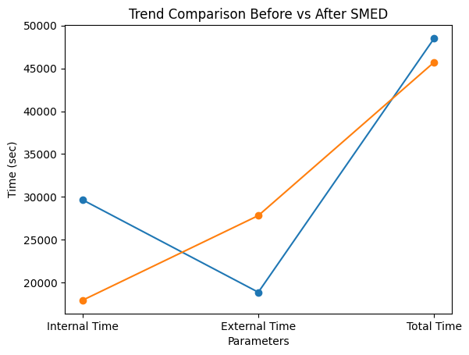

6.3 WEB APPLICATION FOR DIGITAL KANBAN

PUT ALL THE UPDATED AND FINAL POSSIBLE SS OF WEB APP AND BELOW THE IMAGE EXPLAIN IT PROPERLY .

6.4 CPM (COST PER MINUTE)

1. Given Data

Parameter | Value
Total Budget per factory | ₹14,00,000 INR
Manpower | 160
Working Days | 26 (standard)
Working Hours/Day | 9 hours
Efficiency (Initial) | 80%

2. Step-by-Step Calculations

🔹 Step 1: Total Available Minutes
Total Minutes =160×26×9×60
=22,46,400 minutes

🔹 Step 2: Effective Minutes (at 80% efficiency)
Effective Minutes =22,46,400×0.80
=17,97,120 minutes

🔹 Step 3: Initial CPM
CPM = 14,00,000/17,97,120
≈₹0.78 per minute

CPM Calculation After Efficiency Improvement (SMED Impact)

1. Given Data

Parameter | Value
Total Budget | ₹14,00,000
Manpower | 160
Working Days | 26
Working Hours/Day | 9
Initial Efficiency | 80%
Efficiency Improvement | +11%

2. New Efficiency

New Efficiency = 80% + 11% = 91%

3. Total Available Minutes

Total Minutes = 160 × 26 × 9 × 60
=22,46,400 minutes

4. BEFORE SMED (Initial Condition)

🔹 Effective Minutes

Effective Minutes = 22,46,400 × 0.80
= 17,97,120 minutes

🔹 Initial CPM

CPM = 14,00,000/17,97,120
≈₹0.78 per minute

5. AFTER SMED (Improved Condition)
- Effective Minutes
Effective Minutes = 22,46,400 × 0.91
= 20,44,224 minutes
- New CPM
CPM = 14,00,000/20,44,224
≈₹0.68 per minute

6. Before vs After Comparison

Parameter | Before SMED | After SMED
Efficiency | 80% | 91%
Total Minutes | 22,46,400 | 22,46,400
Effective Minutes | 17,97,120 | 20,44,224
CPM (₹/min) | 0.78 | 0.68

7. CPM Reduction %
Reduction % = 0.78 − 0.68/0.78×100
≈12.82%
CHAPTER 7
DISCUSSION OF FINDINGS

8.1 Observed Benefits of SMED Implementation
The implementation of the Single-Minute Exchange of Dies (SMED) technique in the garment production process has shown significant improvements in operational efficiency and productivity. Based on the analysis conducted throughout the project, the following benefits were observed.

1. Reduced Downtime
One of the primary advantages of SMED is the substantial reduction in machine downtime during style changeovers. By separating internal and external activities and streamlining setup procedures, the time required for changeovers was minimized. This led to better machine utilization and reduced idle time in the production line.

2. Increased Flexibility
SMED enabled the production system to respond quickly to changes in style and order requirements. The garment industry frequently deals with varying designs and small batch production; hence, improved flexibility allowed the unit to switch between styles efficiently without affecting productivity.

3. Faster Production Rate
With reduced setup time, more time was available for actual production. This resulted in an increase in the number of garments produced within the same time frame. Faster changeovers also ensured that production schedules were met more consistently.

4. Improved Workflow Standardization
The implementation encouraged the standardization of setup procedures. Clearly defined steps reduced confusion among workers and ensured consistency in operations across different shifts.

5. Better Resource Utilization
SMED reduced unnecessary movements, delays, and inefficiencies. This led to optimal use of manpower, machines, and materials, thereby improving overall operational performance.

8.2 Challenges Faced During Implementation
Despite the benefits, several challenges were encountered during the implementation of SMED in the garment production environment:

1. Worker Resistance to Change
Workers were initially resistant to adopting new methods and procedures. Since they were accustomed to traditional working styles, introducing standardized processes required time and continuous motivation.

2. Training and Skill Development
SMED implementation required proper training of workers to understand new setup procedures and techniques. Conducting training sessions and ensuring that all workers followed the updated process was a significant challenge.

3. Initial Time Investment
In the early stages, analyzing processes, recording data, and redesigning workflows required additional time and effort. This temporarily affected production efficiency.

4. Coordination Between Departments
Effective SMED implementation required coordination between different departments such as cutting, sewing, and finishing. Lack of communication initially led to delays.

5. Maintaining Consistency
Ensuring that standardized procedures were followed consistently over time was difficult. Continuous monitoring and supervision were required to sustain improvements.

CHAPTER 8
LIMITATIONS AND FUTURE SCOPE

9.1 Limitations of the Study
Despite achieving the objectives of analyzing and improving garment production efficiency using SMED principles and a web-based system, the study has certain limitations:
- Limited Data Scope
The study is based on a specific set of production data collected from a controlled or sample environment. It may not fully represent large-scale garment industries with diverse product lines.
- Time Constraints
Due to academic project timelines, long-term observation of improvements after SMED implementation was not possible.
- Simulation-Based Implementation
The SMED methodology was partially demonstrated through analysis and system design rather than full real-time industrial deployment.
- Dependency on Input Accuracy
The effectiveness of the web system depends on accurate data entry (running styles, upcoming styles, changeover time, etc.). Incorrect inputs may affect results.
- Limited Automation
The current system focuses more on monitoring and analysis rather than fully automated decision-making or machine integration.
- Technology Constraints
The web application (localhost-based) is not yet deployed on a live server, limiting accessibility and real-time industrial usability.
- User Adaptability
Workers and supervisors may require training to effectively use the system and understand SMED concepts.
- Lack of IoT/Real-Time Data Integration
The system does not currently integrate with sensors or machines for real-time tracking of production or changeover time.

9.2 Scope for Future Research
The project provides a strong foundation for further improvements and real-world implementation. Future enhancements can significantly increase its impact:
- Integration with IoT and Smart Machines
Connect machines with sensors to automatically capture changeover time, production speed, and downtime.
- AI-Based Optimization
Use Artificial Intelligence to predict optimal changeover strategies and reduce setup time further.
- Cloud-Based Deployment
Convert the localhost system into a cloud-based platform for access across multiple factories and locations.
- Advanced Data Analytics Dashboard
Add visual dashboards with graphs, KPIs, and performance insights for better decision-making.
- Mobile Application Development
Develop a mobile-friendly version for supervisors to track production on the shop floor.
- Automation of SMED Suggestions
Enable the system to automatically suggest improvements based on historical data and patterns.
- Scalability for Multiple Production Lines
Expand the system to handle multiple lines, departments, and factories simultaneously.
- Integration with ERP Systems
Link the application with existing ERP systems for seamless production planning and tracking.
- Sustainability Analysis
Extend the system to include carbon and water footprint analysis for eco-friendly garment production.

CHAPTER 9

CONCLUSION

This project focused on improving production efficiency using SMED principles and analyzing bobbin-related operations. The study identified inefficiencies in the setup process and reduced changeover time by converting internal activities into external ones.
Key outcomes include:
- Reduction in setup and idle time
- Improved machine utilization and workflow
- Optimization of bobbin handling and material flow
- Increase in overall productivity and efficiency
- Reduction in non-value-added activities
The implementation of SMED proved effective in enhancing operational performance with minimal resources. The project highlights the importance of continuous improvement, standardization, and operator involvement.
Further improvements can be achieved through regular monitoring and adoption of advanced technologies. Overall, the study demonstrates the practical benefits of lean manufacturing in improving productivity.

CHAPTER 10
REFERENCES
• Almomani, M.A. (2013). A proposed approach for setup time reduction through SMED. Journal of Manufacturing Systems.
• Mohammad, A. et al. (2023). Reduction of changeover time through SMED with RACI method. International Journal of Lean Six Sigma.
• Bajpai, J.D. (2014). SMED methodology in garment manufacturing industry: A case study.
• Jan, F. (2016). Application of SMED methodology in manufacturing industries.
• Dogan, O. (2018). Decision Support System for SMED implementation.
• Cakmakci, M. (2009). Process capability analysis using SMED methodology.
• Womack, J.P. & Jones, D.T. (2003). Lean Thinking. Simon & Schuster.
• Ohno, T. (1988). Toyota Production System: Beyond Large-Scale Production. CRC Press.
• Monden, Y. (1984). Toyota Production System. Industrial Engineering Press.
• Moxham, C. & Greatbanks, R. (2001). SMED application in textile processing industry.
• Groyyo Consulting (2022). SMED in apparel production: Agile manufacturing approach.

